Wei Da Chen
Visual Design
Your Toolkit

About This Toolkit
How to Use
To get started with this toolkit:
- Click File > Make a copy… in the upper-left corner.
- Give the file a title that includes your first and last name.
- Click OK.
- The toolkit is now saved to your Google Drive account, where you’ll be able to edit it.

Your Project Challenge
You’ve done the research, prototyping, and testing. Now it’s time to think about your project’s visual design.

This toolkit provides resources to help you:
- Improve your prototype by incorporating essential design elements.

- Create a color palette for your design.

- Select an appropriate font based on context, desired feel, or brand guidelines.

Essential Design Concepts
Use the chart below to record at least two changes you would make to improve your prototype’s design. Use the seven tenets you explored in the Essential Concepts for Design lesson.

Describe the change. | What concept(s) does it uphold? | Why did you suggest this change? How does it impact the user?
Round the corners of all call to actions (buttons). | Repetition | Styling all buttons with the same shape will make it easier for the user to navigate through the interface.
Colored all of my buttons the same color as my logo. | Repetition | Coloring all buttons with the same color will make it easier for the user to identify and locate useful buttons.`
Placed all buttons in the same sections of each page. | Repetition | Users will know where the important buttons are even before jumping onto the next page.
I adjusted the images and placement of buttons in my opening images. | Composition | Combining imagery, text, color, shape, pattern, and texture makes the result more appealing and functional.

Choosing a Palette
Use your persona to help inform your product’s color palette. Include the Pantone number or Hex code of each color, as well as a visual representation (e.g., an image or paint fill icon).

Describe your persona.  (Demographics, challenges, goals, needs, etc.) | Choose a dominant color. | Share your color palette using one cell per color. You can add or remove cells based on the number of colors. | Explain why you chose this palette.
- My persona consists of travelers or people looking to travel between the ages of 20 - 60 year-olds. | 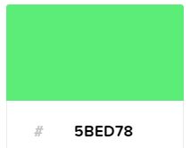 |  | I chose this analogous palette (main color and two colors next to it) because it does a great job of communicating consistency and uniformity within the design.
 |  | 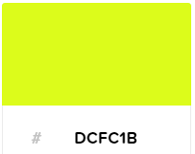
 |  | 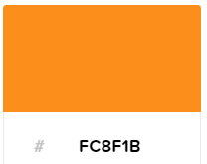

Choosing a Typeface
Jot down your choice of typeface, font, and where and how you will use it.

Provide one explanation for why you chose the typeface(s) you did. Add a row if you plan to include more than one.

Which typeface will you use? | Which fonts? | Where? How? | Why?
- Traditional Serif | - Roboto Mono | - For pages that display instructions | - Unique typefaces stand out to the human eye which makes the users pay extra attention

